Discover Gloversville  Uncover the City’s Hidden Treasures  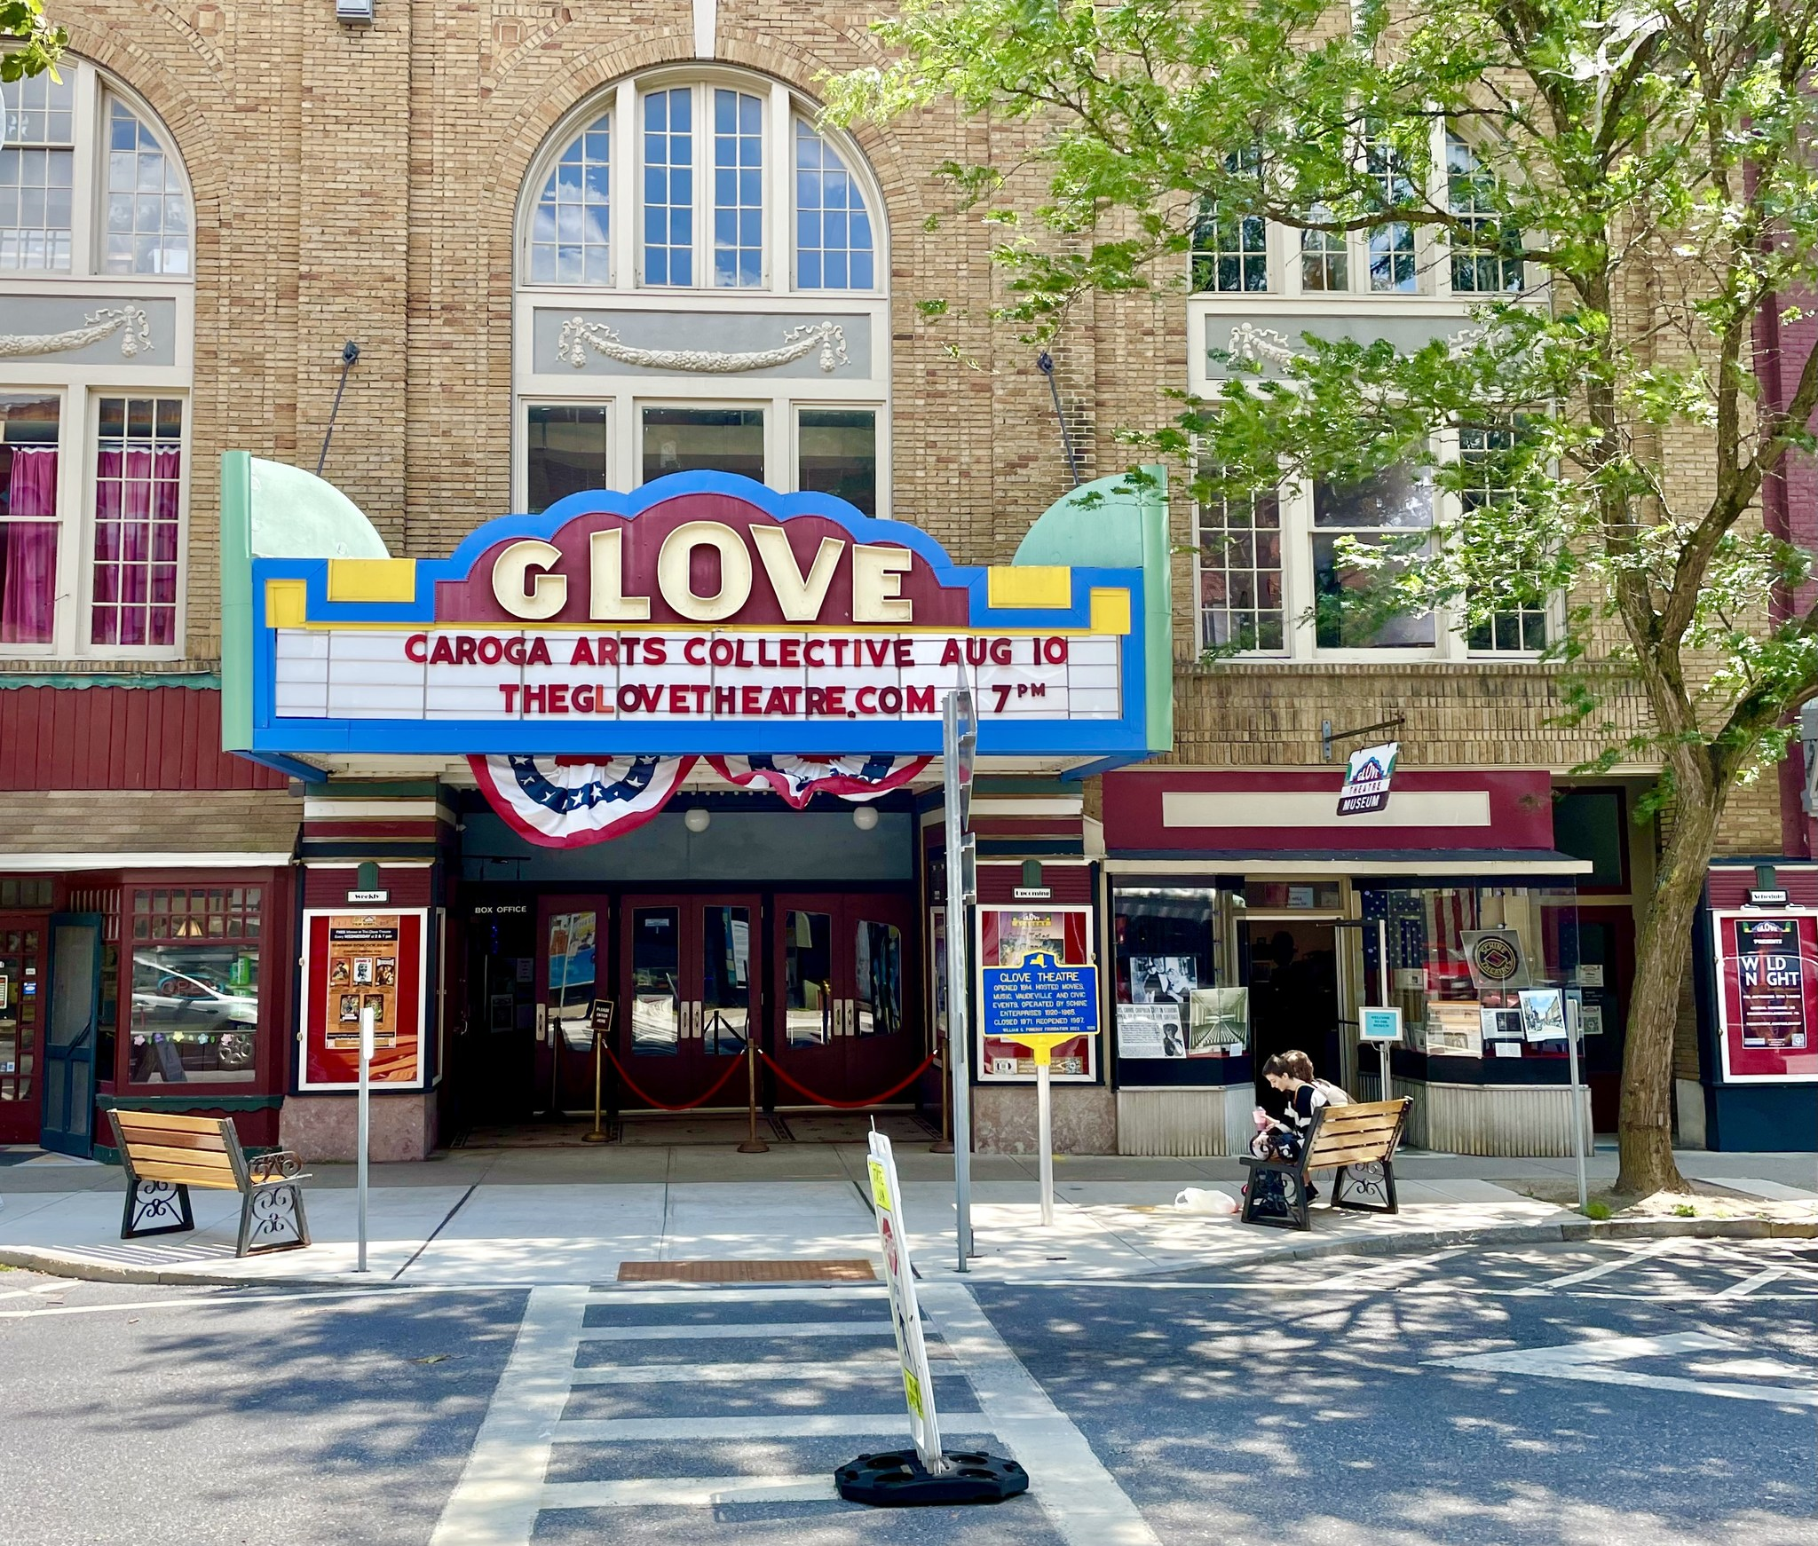  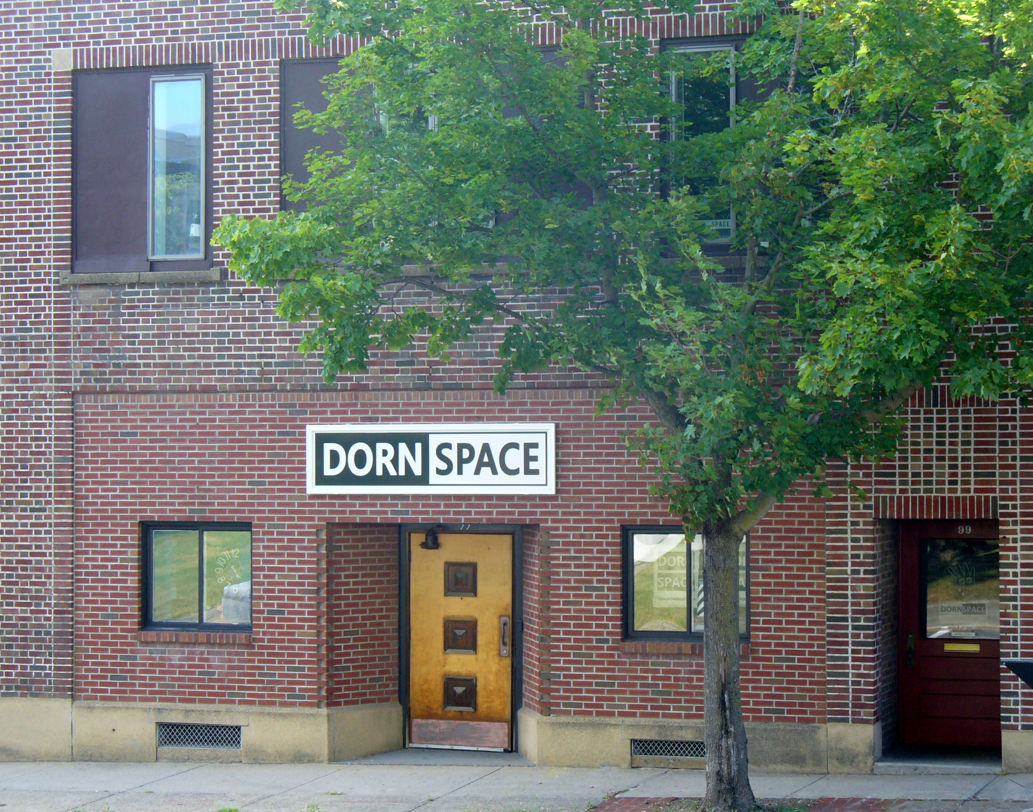  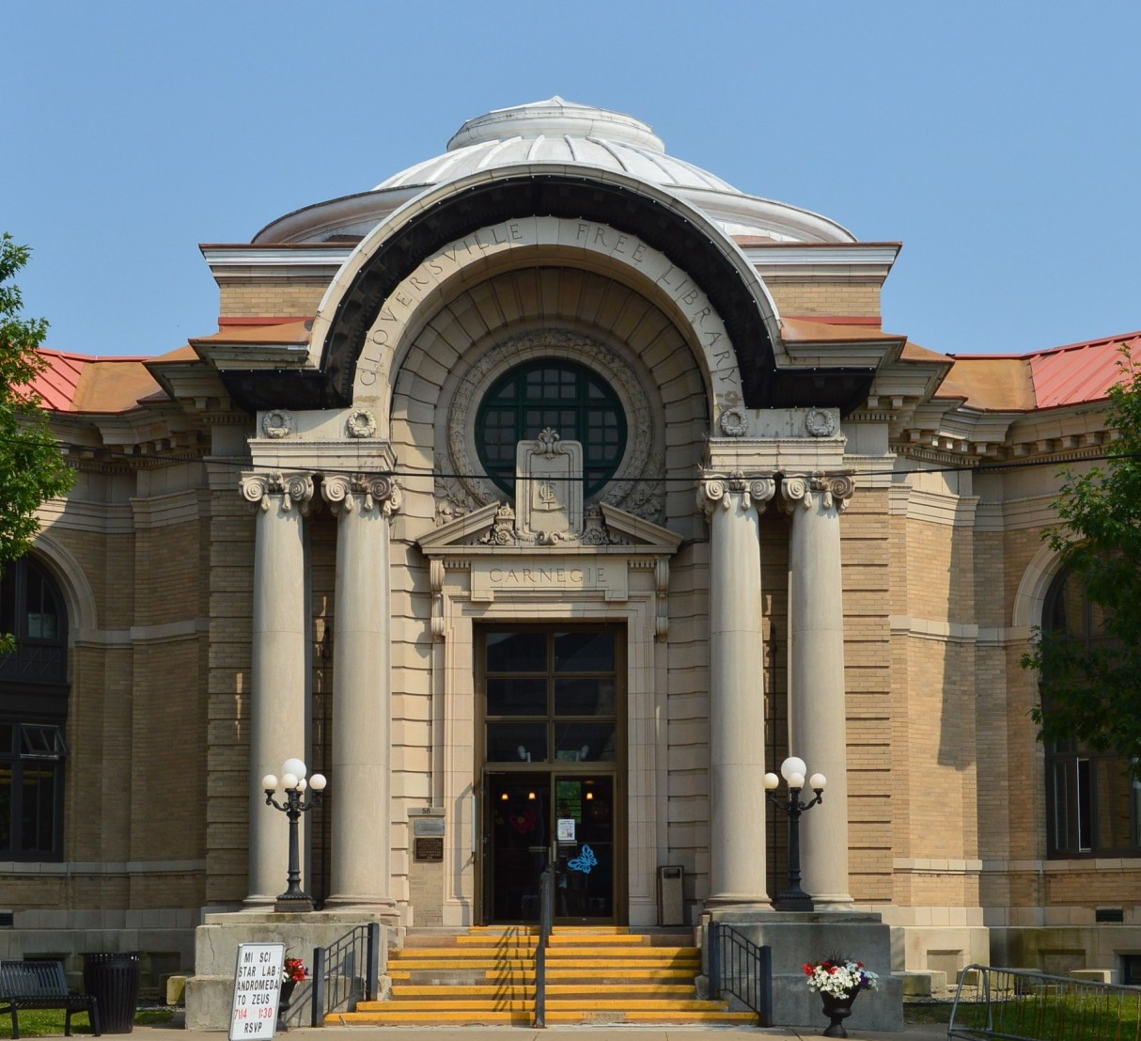 | Discover Gloversville  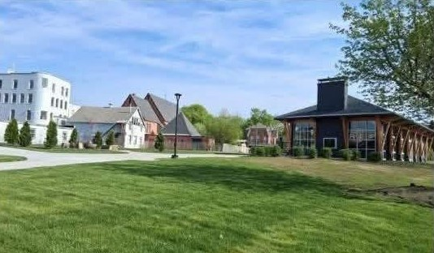  See what Gloversville has to offer  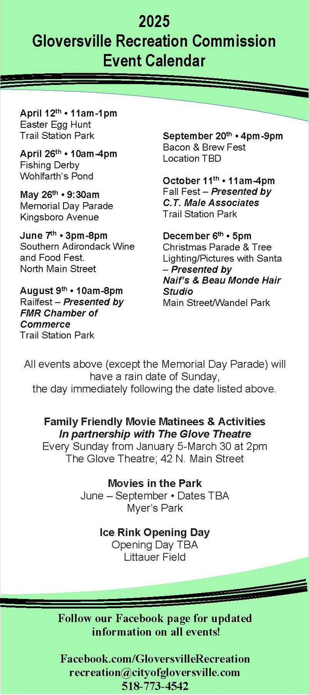 | Discover Gloversville  Small  Business  Directory  Explore the Gems of Gloversville  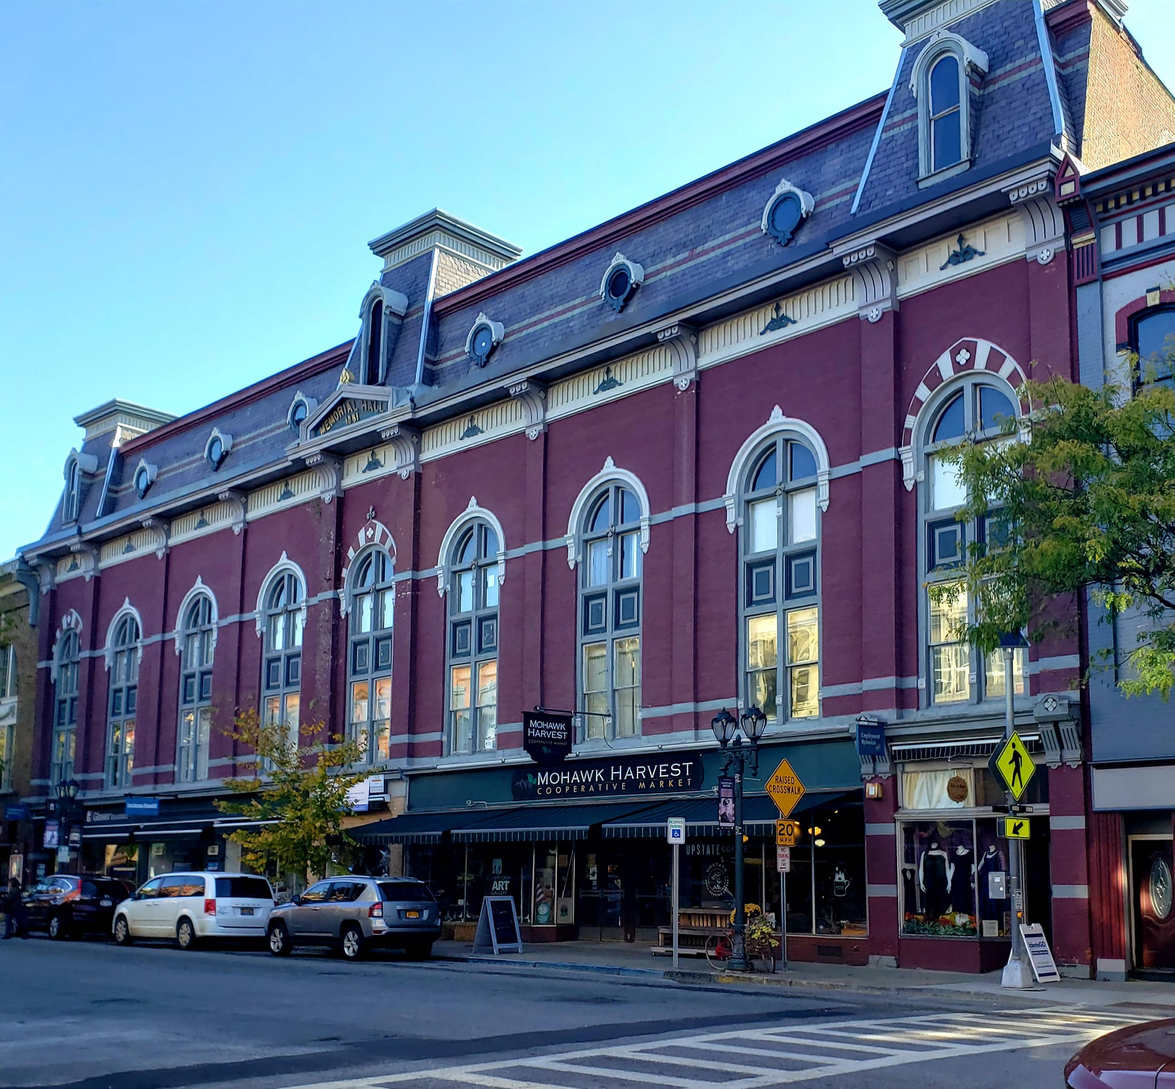

- Services  Addictive Pain Tattoo, 29 N. Main St.  Adirondack Massage Therapist, 40 N. Main St.  Anne Campbell NP in Health, 7 Church St.  Be Well With Donna, 26 N. Main St.  Beau Monde Hair & Day Spa, 235 N. Main St.  Capano’s Hairitage Salon, 31 Bleecker St.  Chad Majewski Real Estate, 51 N. Main St.  Doll House Hair Salon, 97 E. Fulton St.  Fulton County Barbershop, 19 N. Main St.  Gloversville Pharmacy, 42 N. Main St.  Gloversville Public Library, 58 E. Fulton St.  Glover Insurance Agency, 38 N. Main St.  Go For It Fitness, 7 Church St.  Golden Garden Parties, 34 N. Main St.  H&R Block, 35-37 N. Main St.  Jackson Hewitt Tax Service, 36 N. Main St.  Jaime Retersdorf, BS, LMT, 26 N. Main St.  K. Morrison & Sons Barber, 7 Church St.  NBT Bank, 12 Fremont St.  Ricmar Design & Print Shop, 31 N. Main St.  Rooney Signs, 47 Washington St.  SW the Spa, 23 Fremont St.  The Beauty Cauldron, 30 S. Main St.  The Lab & Venue 91, 91 N. Main St.  - Parks  Castiglione Memorial Park, 53 N. Main St.  Darling Field, Tennis, PickleBall, 198 Kingsboro  Elk Street Park & Basketball, 110 E. Fulton St.  Trail Station Park & Splash Pad, W. Fulton St.  Little Husky Field, 27 Union St.  Melchior Park, 94 Kingsboro Ave.  Meyer’s Park, 50 Bloomingdale Ave.  South Main Street Piazza, 10-12 S. Main St.  Spring Street Park, 139 Spring St.  St. Thomas Square, 2- 8 Elm St.  The Community Garden, 110 Fremont St.  Veterans Park, 256 Kingsboro Ave.  Wandel Park, 14 Spring St.  Washington Street Park, 127 Washington St.  Wohlfarths Pond, 44 S. McNab Ave. | - Food & Drink  Aaron’s Irish Pub, 231 N. Main St.  Adirondack Soul Company, 60 N. Main St  Brass Monkey, 52 Cayadutta St.  Buck’s Pizza, 23 N. Main St.  Ceasars Pizza Restaurant, 235 N. Main St.  Caboose, 99 ½ W. Fulton St.  Cravings Bakery & Café, 47 Cayadutta St.  El Mezcal Taqueria & Bar, 97 S. Main St.  Eva’s Soulfood, 116 S. Main St.  Harold’s Restaurant, 176 W. Fulton St.  House Chen, 267 N. Main St.  Jimmy’s Deli & Grocery, 78 N. Main St.  Sage & Cedar Café, 33 N. Main St.  Off the Rails Tavern, 7 West St.  Milo’s Italian Deli, 80 W. 8th Ave.  New York Lunch, 21 Bleecker St.  Palace Diner, 62 S. Main St.  Peking Chinese Restaurant, 40 Church St.  Pizza Joint, 151 N. Main St.  Plaza Deli Plus, 50 Church St.  The Railyard, 97 W. Fulton St.  The Upper Deck Bar, 1 West St.  - Experiences  Carol’s Cameos Dance, 184 W. Fulton St.  Dorn Space, 99 N. Main St.  Fulton County Museum, 237 Kingsboro Ave.  Gloversville Farmer’s Market, 2-8 Elm St.  Matti Bright Studio, 11 Church St.  NYS Baseball Hall of Fame, 45 Harrison St.  Parkhurst Field, 50 Harrison St.  The Glove Theatre, 42 N. Main St.  The Glove Theatre Museum, 42 N. Main St.  The Shoeleather Express, 31 Spring St.  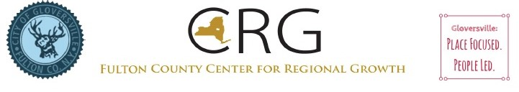 | - Shopping  2 of Cups Couture, 26 N. Main St.  44 Lakes Customized Gifts, 15 N. Main St.  47 Marketplace Convenience, 47 N. Main St.  Adirondack Stained Glass, 29 E. Fulton St.  Bowman’s Market, 50 E. Pine St.  Dunday’s Mens Clothing Store, 49 N. Main St.  East Fulton Wine & Liquor, 86 E. Fulton St.  EmpowHERing Designs, 47 S. Main St.  Garcias, 84 N. Main St.  Gloversville Sewing Center, 385 N. Main St.  Great Rentals, 59 N. Main St.  Helpers Community Store, 55 S. Main St.  Josh’s Cellular Care & Repair, 95 E. Fulton St.  Livingston’s Furniture, 355 S. Main St.  Micropolis Art Gallery, 30 N. Main St.  Mohawk Harvest Co-op Market, 30 N. Main St.  Naif’s Convenience Store, 251 N. Main St.  Ralph’s Tailor Shop, 43 N. Main St.  Rauch Bakery, 15 Washington St.  Rossbach Shoe Store, 10 W. Fulton St.  Salvation Army Thrift Shop, 43 W. Fulton St.  TJ’s Discount Beverage, 86 E. Fulton St,  The Fly Shack, 28 E. Fulton St.  True Value, 25 Bleecker St.  Upstate RC and Hobbies, 91 N. Main St.  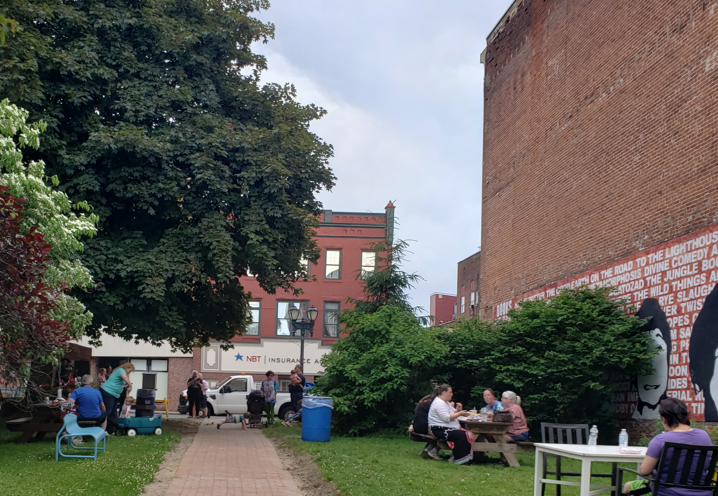  .Visit  www.cityofgloversville.com  www.downtowngloversville.org

